1. **Exploration Of Final_Monthly Dataset - Insights Into Different Customer Segments By Their Behavior.**

**Customer_Status Segment Plot**

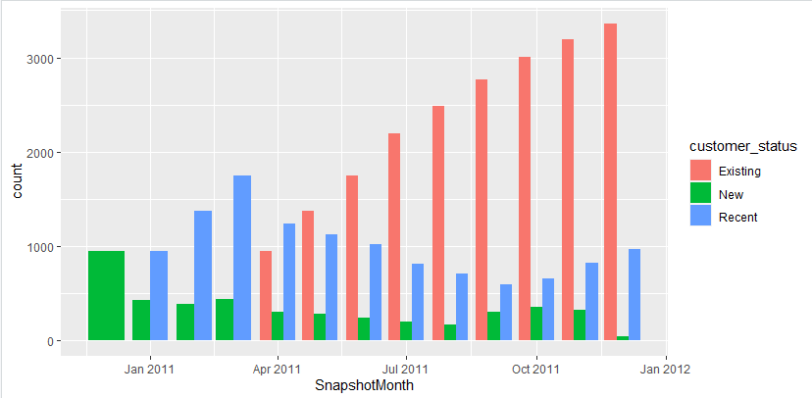

The Existing customers are growing which is expected as there are New and recent segments every month and there is not much info we can gather from that information alone. But its interesting to notice that the new segment has been decreasing from January till August and then a slight pickup but not drastic. A similar trend can be seen for the Recent segment as well. This is an area of concern as to why there has not been an increase in new customers…Are the products being offered not attractive? Is the cost of the products too high? Is the customer service not good? These are some of the areas that can cause a decrease in new customers and its worth exploring more on these areas.

**Retention status segment.Plot**

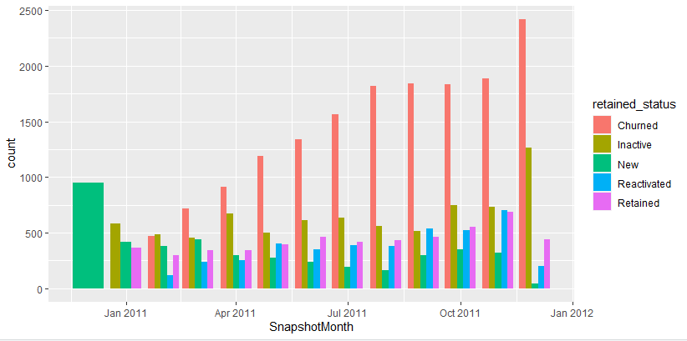

The company has been successful to only retain under 500 customers on a consistent basis over the 12 months.

The reactivated count increases slightly from Feb to May to around 400 and then drops slightly and maintains that count for 3 months till August. Then there is a small spike from September to November and then drops in December.

The inactive and Churned customers are showing an alarming increasing trend. More analysis on these customers on what products they purchased, their feedback and any issues they might have had can give some insight to the reason for the trend.

**Retention Rates Trend**

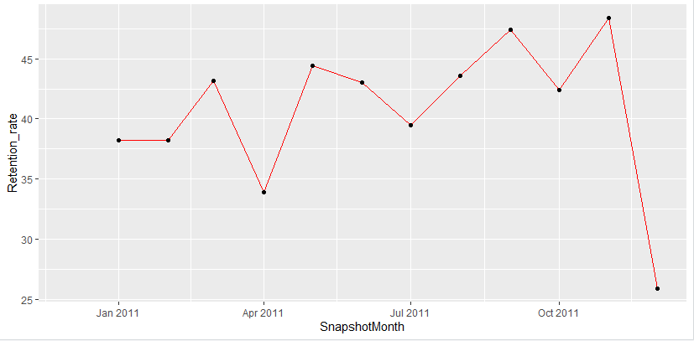

This plot gives a more detailed overview of how the retention rates have been in the 12 months, which was observed in the bar chart earlier. The retention has increased at slow rate from 38% to 48% till November after which it has dipped. But we can say it is consistent throughout the 12 months with no significant upward trend. The fact that 52% of the customers are currently not retained for the next month is important information that this area needs further analysis which the company needs to work on to improve sales. More sales and marketing activities may need to be done to retain existing customers.

**Reactivation Rates Trend**

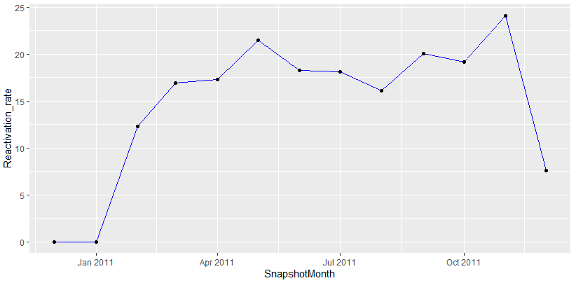

This plot gives a more detailed overview of how the reactivation rates have been in the 12 months, which was observed in the bar chart earlier. The reactivation has increased at slow rate up to 25% till November after which it has dipped. But we can say it is consistent throughout the 12 months with no significant upward trend . The fact that 75% of the customers who didn’t make a transaction last month are falling under the churned segment, is worrying. As mentioned earlier more sales and marketing activities may need to be done to retain them.

**Product status segment Plot**

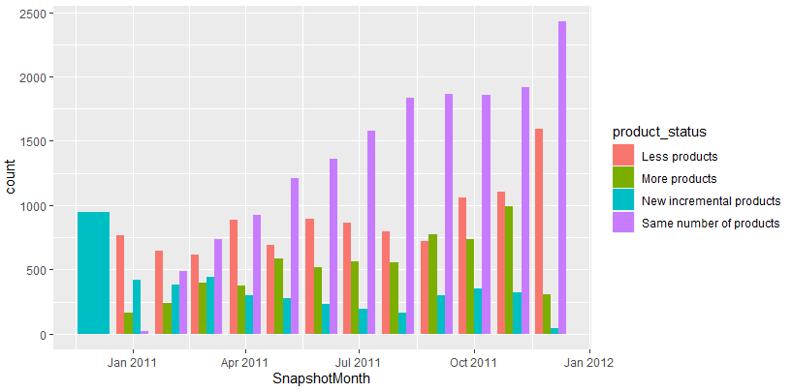

The rate of customers buying less type of products or same number of type of products is increasing at a constant rate while, the customers buying more type of products is maintaining a constant status. This more product segment could be a handful of loyal customers. Here again the customers who are buying less or same number of products need to be targeted with more sales offers, to convert them into the more product segment.

**Customer Segments**

For the business to grow, it is important to want customers who are as profitable as possible. Some of the keyways to identify these customers is to segment customers according to :

* Total quantity they purchased (Top quantity Segment)
* The average value of a typical transaction (Basket Segment)
* The amount spent on all purchases by the customer ever (Total value Segment)

By analyzing these records, we can assess how profitable each customer segment is. Are just a few customers responsible for all the profits or are some of the largest customers among the least profitable or whether customers you would be better off without.

Analyzing the business customer background and product likes from this data especially if the business customer is expanding is important as he/she may become more profitable for the company in the future.

**Top Quantity Segment**

The segment will be split as

* **Top Quantity Segment** - customers who have in total bought more or equal 2000 units.
* **Frequency segment** - customers who have in total bought between 500 and 2000 total units
* **Average segment -** customers who have in total bought between 100 and 500 total units
* **Low quantity segment-** customers who have in total bought between 0 and 100 total units
* **Negative quantity segment-** customers who have in total bought negative units. These are the customers who have high returns and a segment the company should be avoiding business within future.

**Basket Segment**

The segment will be split as

* Merry Shopper – customers who have an average value of a typical transaction of more than $150
* Big Shopper – customers who have an average value of a typical transaction between $50 and $150
* Average Shopper – customers who have an average value of a typical transaction between $10 and $50
* Thrifty Shopper – customers who have an average value of a typical transaction between $0 and $10
* Fussy Shopper – customers who have an average value of a typical transaction of less than $0. These are customers who could be cancelling their purchases or asking for refunds.

**Total Value Segment**

The segment will be split as

* Diamond Customer – customers who have a total currency amount spent on all purchases of more than $150
* Gold Shopper – customers who have a total currency amount spent on all purchases of between $50 and $150
* Silver Shopper – customers who have a total currency amount spent on all purchases of between $10 and $50
* Bronze Shopper – customers who have a total currency amount spent on all purchases of between $0 and $10
* Casual Shopper– customers who have a total currency amount spent on all purchases of less than $0. These are customers who could be cancelling their purchases or asking for refunds or company has paid them compensation.

1. **Insights from Company Metrics which have Increased and Decreased**

**Top Quantity Segment**

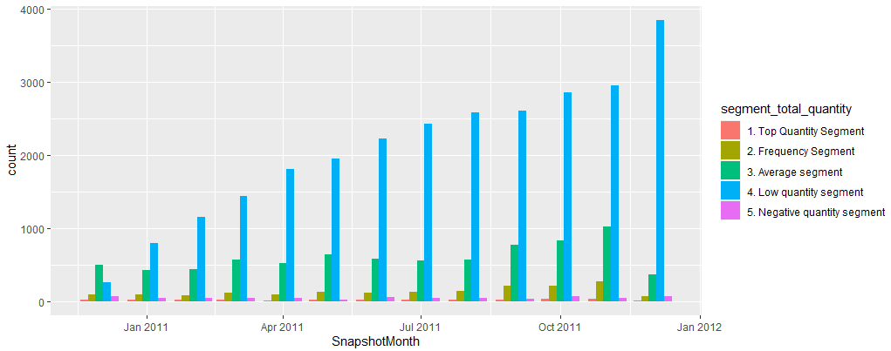

**Basket Segment**

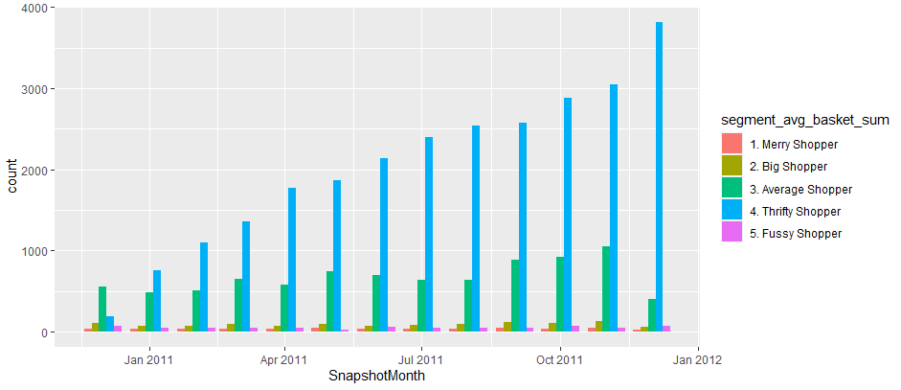

**Total Value Segment**

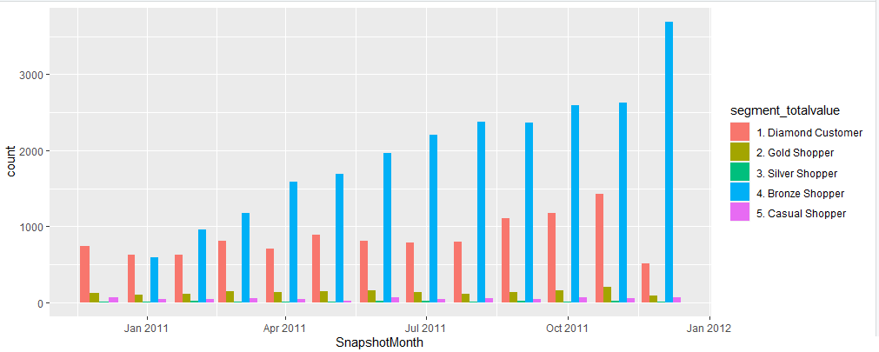

**Increase Drivers**

1. **Customer_Status Segment**

The Existing customer segment is growing at 5 times the original which is expected and there isn’t much info we can gather from the increasing trend plot.

1. **Retention status segment**

The churned segment is significantly a high increase segment and is not just a one-off bump. From around 1000 counts in January to over 3000 in December, it has tripled. It is important to understand the reason for the churn and work on action plans to get these customers back into reactivated segment. The company would need to allocate resources and fund in decreasing this churned segment and increasing the reactivated segment.

1. **Product status segment**

The same number segment is a significantly high increase segment and is not just a one-off bump. From an around 500 counts in January to over 2500 in December, it has increased 5 times. Looking at the existing customer status segment which has the same increase ratio, we can infer the existing customer segment are all just buying the same type of products that they have been buying all these months. It is important to understand the reason why customers are not buying more type of products – is it a cost issue? Are the products cheaper elsewhere or are the quality of the other products off the mark in comparison to other sources? Actions plans must be done on the results of the analysis to get these customers back into more product segment. The company would need to allocate resources and fund in keeping the same segment segment and working on eventually converting them into the more product segment.

1. **Top Quantity Segment**

The Low quantity segment, which is thecustomers who have in total bought between 0 and 100 total units are increasing. From around 250 counts in January to over 4000 in December, it has increased twelve times. It is important to understand the reason for what is causing this trend. Does this segment have a high ratio of Inactive and churned segments causing the quantity segment to stagnate for many customer groups? Since the new customer status segment, is not increasing at a similar rate, it is the existing and recent segment who are contributing to this number. This indirectly means the monthly quantity purchased by new and existing customers is in decline. The company would need to allocate resources and fund in converting this low quantity segment into top quantity segment.

1. **Basket Segment**

The Thrifty Shopper segment that is the customers who have an average value of a typical transaction between $0 and $10 are the one increasing from 200 almost 4000 which is twenty times. Are people just testing our products and then flocking elsewhere? How many of the recent customer status segment contribute to this? The company would need to allocate resources and fund in converting the thrifty segment to the merry shopper segment.

1. **Total Value Segment**

The Bronze Shopper segment that is the customers who has a total currency amount spent on all purchases between $0 and $10 are the one increasing from 500 almost 4000 which is eight times. Are these the same people in the segment of thrifty shopper segment? Are they in the Inactive and churned segments? The company would need to allocate resources and fund in converting the bronze shopper and increasing the diamond segment. The diamond customer has been increasing slightly. The company needs to do invest in more sales offers to retain this segment.

**Decrease Drivers**

Only the customer status segment was a decrease driver.

1. **Customer_Status Segment**

The New and recent customer segment is low and decreasing over the month. The company needs to attract more customers to make purchases of the products. The company would need to allocate resources and fund in increasing these two segments.

1. **Retention status segment**

The inactive, reactivated and retained segments have been consistent.

1. **Product status segment**

The less, More and New incremental segments have been consistent.

1. **Top Quantity Segment**

The Top Quantity, Frequency, Average, and negative quantity segments have been consistent.

1. **Basket Segment**

The Merry, Big, Average, and fussy Shopper segments have been consistent.

1. **Total Value Segment**

The Diamond, Gold, Silver and Casual Shopper segments have been consistent

1. **Segments Generating Largest Monthly Total Quantity**
2. **Customer_Status Segment**
3. **With Total Quantity Comparison**

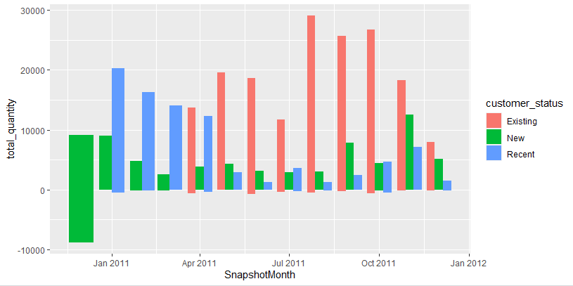

In the months of Jan- March, the Recent segment generated the largest monthly quantity. This is understandable as we defined Recent as those customers within the last 2 months, and we do not have previous data to compare. In subsequent months existing customers generated the largest monthly total quantity and we can observe a drop in the total quantity generated by New and recent customers. Is there a reason like a competitor who is having more attractive similar products and thus new customers are just fishing instead of really being loyal customers? There is a one-off increase in total quantity generated by new customers. This phenomenon could be due to the Christmas sales or holiday shopping.

1. **With Basket Size Comparison**

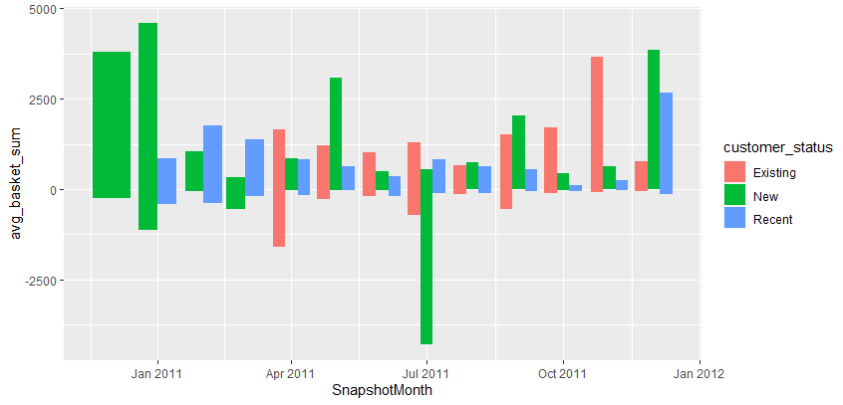

There is not a consistent pattern or trend for the Basket size between each of the customer status segments. All three segments average out to around the same. This shows that the existing customers must have done more transactions to make up for the consistent basket size to achieve a higher total quantity. This is good news as the company has been able to maintain a fair number of loyal customers who are repeatedly buying from the company.

1. **Retention status segment**
2. **With Total Quantity Comparison**

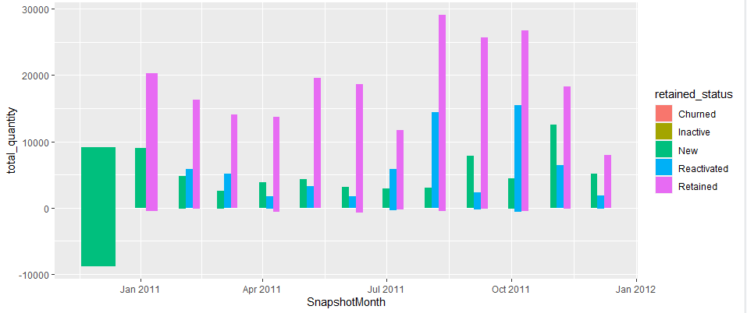

In most of the months the retained segment is contributing to the bulk of the total quantity generated. The Reactivated segment had two spikes in August and September. A deep dive must be done in these 2 months to see what spurred the increase in quantity purchase in the Reactivated segment and whether the company can initiate similar scenario to sustain that effect.

1. **With Basket Size Comparison**

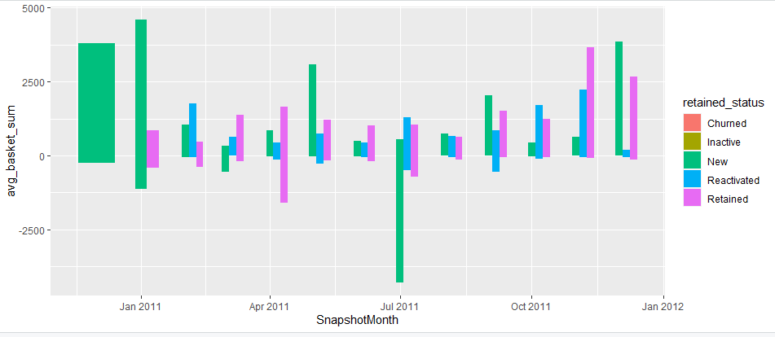

There is not a consistent pattern or trend for the Basket size between each of the retained status segments. All three segments average out to around the same. There is an abnormal negative basket sum for July in the new segment which needs to be analyzed.

1. **Product status segment**
2. **With Total Quantity Comparison**

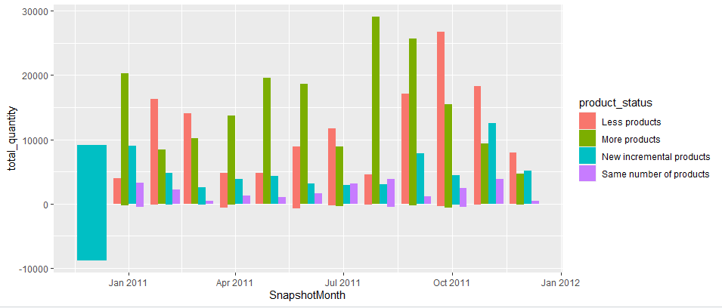

In most of the months, the more products segment generated the largest monthly quantity, followed by customer segment who bought less products.

1. **With Basket Size Comparison**

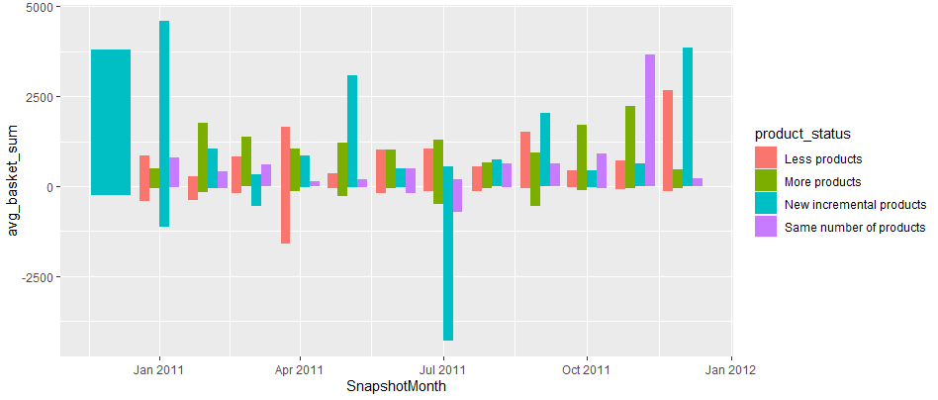

The basket sum of the more products segment is around consistently the same. This again validates that there is a group of loyal customers who are increasing their product quantity as well as the number of transactions. Getting more feedback from these customers and studying their likes and interests as to what makes them comeback for more purchases can give some insight to what action plans the team needs to implement to convert more customers to these segments.

1. **Total Value Segment**
2. **With Total Quantity Comparison**

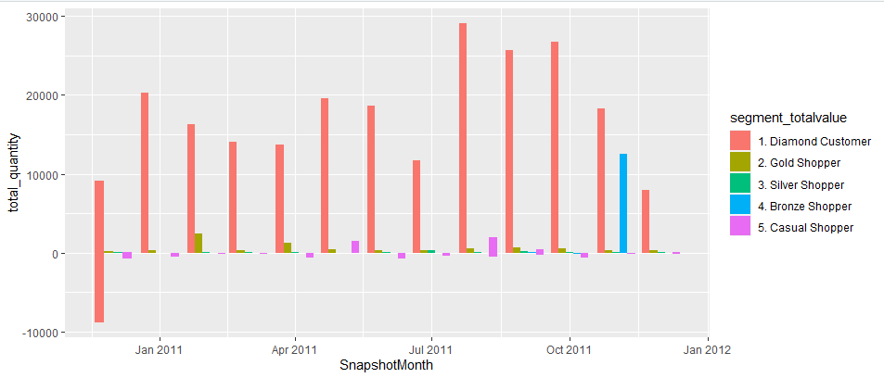

The Diamond Customer contributes the most to generating the total quantity.

1. **With Basket Size Comparison**

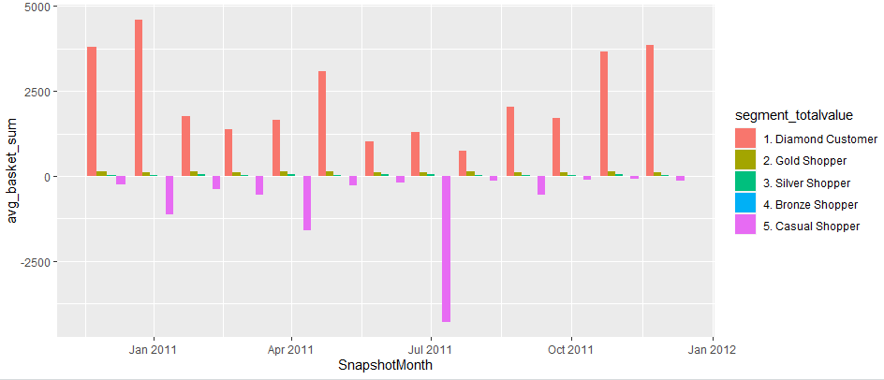

The diamond customer is also the main contributor to the higher average basket sum. We may want to omit and restrict the casual shopper segment while promoting and giving more incentives to the Diamond segment customer.

1. **Recommendations**

Our recommendation is the business would need to spend project dollars to concentrate on three main areas as follows from the findings and insights uncovered from the data analysis.

**Attract More Customers**

The New and Recent segments are on a decline in last 12 months. We are currently only retaining our existing clients. This is an area of concern and a deep dive study on the reasons why this trend is happening needs to be put into place immedietely.

**Retaining More Customers**

The Inactive and Churned customer segments are showing an alarming increasing trend. It is crucial to understand what issues these segments face while purchasing, their feedback on the products and payment processes to help in working out action plans to get these customers back into reactivated segment to increase the revenue for the company. The company would need to allocate resources and fund to initiate more sales and marketing activities.

The company has been able to maintain a fair number of loyal customers who are repeatedly buying from the company. Getting more feedback from these customers or their likes and interests as to what makes them comeback can give some insight to what action plans the team needs to implement to convert more customers to these segments. We may want to omit and restrict the casual shopper segment while promoting and giving more incentives to the Diamond segment customer, to increase their buying interest.

**Product Improvements**

The existing customer segment are just buying the same type of products that they have been buying all these months and the average basket sum of any of the segments other than the Diamond customer is low. It is important to understand the reason the other segment customers are not buying more type of products and quantity of products – what do they need improved in our product offerings? The Thrifty Shopper segment is increasing. Are people just test buying our cheap product or products that they cannot find elsewhere? Or are the products that we are offering not what the customer wants? Sufficient Investment to understand the customer product needs and sourcing and stocking inventory with right kind and quality product is required.